Every year around 3,500 Scottish people of all ages and backgrounds have resuscitation attempted after their heart stops suddenly and unexpectedly - they suffer a cardiac arrest. Currently only 1 in 20 survive. In areas of the world where bystander CPR is the norm, up to 20% of people go home alive after cardiac arrest. Bystander CPR means that the person who is beside the person who has had a cardiac arrest pushes hard and fast on their chest until help arrives from the Ambulance service. If you don’t do CPR then the chances of that person surviving drop by 10% with every minute that passes.1
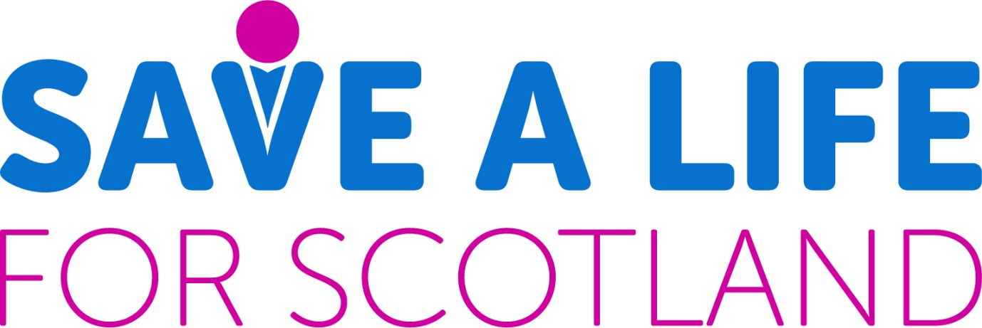
Background
AEDs and associated quick responsive action can save lives. A sudden out of hospital cardiac arrest (OHCA) is the leading cause of death in all developed western countries. The community response to cardiac arrest is critical to saving lives. Each year, UK ambulance services respond to approximately 60,000 cases of suspected cardiac arrest. Resuscitation is attempted by ambulance services in less than half of these cases (approximately 28,000)2, with the population in the Crieff area, there are likely to be approximately 6 cases annually (up to 12 if including visitors).

But, what is an Out of Hospital Cardiac Arrest? A cardiac arrest is an electrical problem which causes a person’s heart to stop beating normally. This isn’t the same as a heart attack, which is a circulatory problem that is caused by a clot forming in an artery supplying blood to the heart muscle.

What is a Defibrillator? A defibrillator gives a high energy electric shock – called defibrillation – to a person’s heart through their chest wall when they are in cardiac arrest. An Automated External Defibrillator (AED) analyses the heart rhythm of a person in cardiac arrest and may apply a shock to enable the patient’s heart to restart, or advise continuing with CPR. An AED gives easy-to-follow guidance to the user, and will not apply a shock if it isn’t needed. Bystander intervention buys time until emergency services arrive, but using an AED is just one element, alongside CPR and others, in helping to save lives. A range of organisations, businesses, clubs, groups and communities across Scotland have already installed an AED. Many make them publicly available and to the emergency services: such Public Access Defibrillators (PADs) are key to strengthening community readiness to respond to an OHCA.

The major factor limiting the number of people who survive OHCA is the ability to provide early cardio pulmonary resuscitation (CPR) and external defibrillation within a critical time. A victim’s chance of survival falls by around 10% with every minute that CPR and defibrillation is delayed. Only rarely are the emergency medical services able to attend and provide defibrillation early enough, and the best way of ensuring prompt defibrillation is for someone nearby to use an AED to deliver the shock that can often save a life. These devices are now widely available and increasingly used by people, often with little or no training, to re-start the heart of a victim of OHCA. Under ideal circumstances, when used very soon after collapse (within two or three minutes), many can survive.

The crucial determinant of survival is the interval between collapse and the use of the AED to deliver a shock. The strategy, therefore, is to have an AED installed at a place where it might be needed so that it can be accessed quickly by someone nearby, taken to the person who has collapsed, and used before the arrival of professional help. This arrangement is known as Public Access Defibrillation (PAD).

These features of AEDs make them suitable for use by members of the public with little or no training, and for use in PAD schemes. As well as having an AED on site (and people trained to use it) is also vital that as many people as possible learn basic skills in cardiopulmonary resuscitation. This entails recognising that someone may have suffered OHCA, calling the emergency services (999 or 112), and then performing chest compressions and rescue breaths. (As part of our proposal a series of training events are provided to the public).

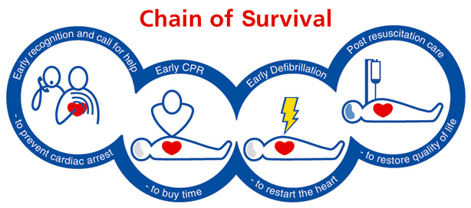

'I saved my teenage son's life with a defibrillator'
By Frances CroninHealth reporter
- 8 August 2018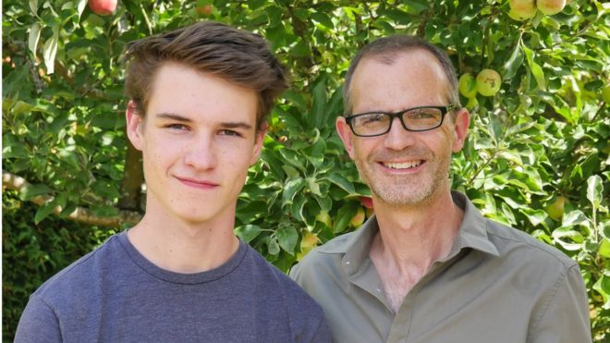
When 15-year-old Ethan Askew started to feel ill in a sports class, he went to tell his teacher and collapsed into his arms - he'd stopped breathing. And it was his Dad who used the school's newly installed defibrillator to help save his life.
At 15, Ethan was a fit and healthy teenager, who went hiking with his dog Treacle and worked towards Duke of Edinburgh awards.
There was no hint of any health problem before his collapse.
Ethan's dad Stuart works as premises manager at the Steiner Academy school which his son attends.
"I was just leaving a meeting when three girls ran up the stairs saying Ethan had collapsed.
"I'm a first-aider at school, and with the number of stubbed toes and things like that you get on a daily basis you don't really worry when somebody says something like that - but I ran down to the field.
"As I was sprinting across, I realised somebody was doing chest compressions on him and it kind of takes a couple of seconds to realise what that truly means.
"I knew how serious it was."

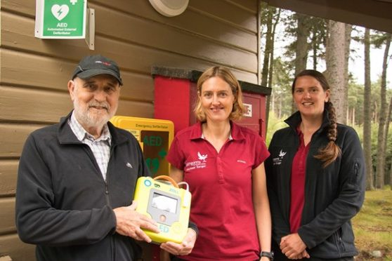
A cyclist who suffered a sudden cardiac arrest on a royal estate has offered heartfelt thanks to the rangers who saved his life by using a public access defibrillator.

The most important consideration is that those who might need to use an AED know where it is kept and how to access it quickly. No barrier should be put in the way of anyone collecting it when it is needed; it should not be locked away and inaccessible.

Our research has identified several AEDs are installed around the town, and some are being planned. However, a range of issues which may result in the death of an OHCA victim in the town could be alleviated with some action. The issues are:
- That many public “hotspots” do not have AEDs near them,
- They are not registered with the Scottish Ambulance Service (SAS),
- Some existing AEDs in Crieff are not available to the public,
- Existing AEDs unavailable to the public if the building is closed e.g. weekends/after 5pm
- Public do not know or have confidence to use them

Proposals
To save lives in danger of having a sudden cardiac arrest are:
- Install AEDs in recommended public spaces (and register with SAS)
- Provide training to the public
- Seek guardians to look after the AEDs
- Seek sponsorship to maintain the AEDs

Following discussions with Scottish Ambulance Service (Community Resilience Department) regarding where to place AEDs in Crieff the following sites were recommended. These provide the best coverage for Crieff, considering the population and potential regular activities, 200m range concentric circles and large footfall.

Recommended sites
- Bottom ,Taylor Park - Macrosty Park, Crieff
- Bridgend (McNees Buildings), Crieff
- High Street (Logos or Pretoria Bar), Crieff
- Dollerie Terrace (Junction of Hollybush Drive), Crieff
- King Street (Outside Post Office / Post Box), Crieff or Co-op
- Strathearn Terrace (outside Crieff Parish Church), Crieff
- Telephone box, Five Roads Junction, Crieff
- Fire Station, Brioch Road, Crieff
- Telephone box, Burrell Street, Crieff

There is understandable concern that an AED in a public place may be at risk of theft or vandalism. Where there is a definite high risk that an AED may be stolen or damaged, any arrangements to protect it will almost certainly create delays in getting it to the person who is in immediate need of it. On the other hand, an AED that has been stolen or damaged will be of no use to anyone. General advice is that AEDs should not be kept locked, but if the risk of theft or vandalism is considered significant, any protective measures must be accompanied by a reliable arrangement to minimize the delay in obtaining access when it is needed.

Costs per AED
 | Purchase | Annual Maint.
Defibrillator cost | 1,200 | 0
Secure unit* | 600 | 0
Fitting est. | 200 | 0
Design branding | 100 | 0
Electricity feeds | 0 | 50
Replacement pads | 0 | 55
Cost | 2,100 | 110

Training
Once AEDs ordered organize and publicise a series of training events for the public. The best places for events to take place will be in existing well used facilities and/or clubs which have type of people most likely to suffer from sudden cardiac arrest (i.e. middle aged men). Suggestions to consider are:

- Crieff Golf Club
- Crieff Bowling Club
- Community Campus
- British Legion, Crieff

PROGRESS TO DATE
Original Plan | Revised
- Telephone box, Five Roads Junction, Crieff  - Telephone box, Burrell Street, Crieff  - Bridgend (McNees Buildings), Crieff  - High Street (Logos, Crieff) | - Complete  - Complete  - Braidhaugh Caravan Park – installed  - Pretoria Bar - installed | Installed & operational
- Bottom ,Taylor Park - Macrosty Park, Crieff  - Fire Station, Brioch Road, Crieff  - Dollerie Terrace (Junction of Hollybush Drive), Crieff | - Cabinet installed, waiting defib  - Agreed, awaiting Fire Scotland & defib.  - Handy Shop – awaiting defib | Ordered and awaiting connection
- King Street (Outside Post Office / Post Box), Crieff or Co-op  - Strathearn Terrace (outside Crieff Parish Church), Crieff | - Station Hotel  - Agreed  - Comrie - tbc | Next phase of defibs
 | - Dollerie Terrace (bottom)  - High Street , Centre/West  - Muthill? | Next phase as funding becomes available

References

- https://www.readyscotland.org/are-you-ready/daily-health-resilience/cpr/
- Perkins GD, Lockey AS, de Belder MA, Moore F, Weissberg P, Gray H. National initiatives to improve outcomes from out of hospital cardiac arrest in England. Emergency Medicine Journal 2015. doi: 10.1136/emermed-2015-204847

